BRAC University
Department of Computer Science and Engineering

Summer– 2005
CSE110 (Programming Language-I)
Lab 4

Task 1:

What is the value of each of the following arithmetic expressions in Java?

a) 3+4.8*2 b) 12%16 c) 2.*6/5 d) 5.2+12/8 e) 4 -(6+18.0/3)/3 f) 17-12*4 g) 2*6/5. h) 7/(4*2) i) 2*6/5 j) 19%13
k) 36/60 l) 2 * pow(3.,2.)

Task 2:

Write Java expression corresponding to each of the following mathematical expressions.

a) 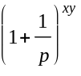 b) 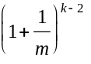 c) 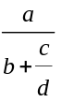 d) a+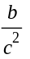 e) 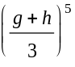
f) 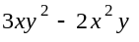 a) 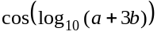 b) 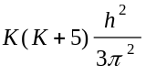 c) 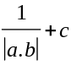 d) 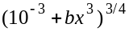 e) 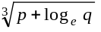 f) 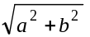 g) 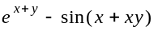

Task 3:

Try the following commands in the Dr. Java “Interactions” pane and report what happens.

byte b;
int i = 257;
double d = 323.142;
b = i;
System.out.println(b);
b = (byte) i;
System.out.println(b);
i = (int) d;
System.out.println(i);
b = (byte) d;
System.out.println(b);

Task 4:

Here is a program that computes the number of miles that light will travel in a specified number of days.

class Light {
public static void Main (string[] Args) {
//approximate speed of light in miles per second
Lightspeed = 186000
days = 1000; //specify number of days here
seconds = Days*24*60*60; /*convert to seconds/
distance = lightspeed * Second; //compute distance
System.out.print("In " + days + “ days light will travel about “);
system.out.println(Distance + "miles.");
}

Try to compile and run the above Java program. If it does not work, make the necessary correction.
[Make sure you have followed Java naming conventions.]

Homework:

a) Write a complete pseudo-code/flowchart of a program, which adds all the multiples of 7 and 9 up to 300.

b) Write a complete pseudo-code/flowchart of a program, which prints the following sequences of values in loops:
- 24, 18, 12, 6, 0
- -10, -5, 0, 5, 10, 15
- 18, 27, 36, 45, 54

c) An integer number is said to be a perfect number if its factors, including 1 but not the number itself, sum to the number. For example, 6 is a perfect number because 6 = 1 + 2 + 3. Write a complete pseudo-code/flowchart of a program, which finds and prints all perfect numbers that are less than 1600.

